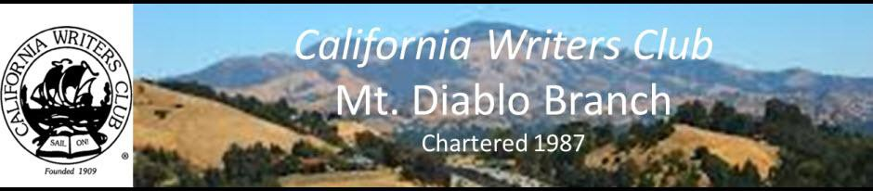

**ZOOMING WORKSHOP**

**March 13, 2021 – Workshop 9:30 am to 12:00**



***Write Your Novel from the Middle: A New Approach for Plotters,***

***Pantsers and Everyone in Between***

## Featuring

**James Scott Bell**

I've been studying plot and structure for over twenty-five years.  And I've plotted in many different ways. I've "pantsed' my way to completed books (no outline or planning) and I've outlined others. I've done it in between, too. So I know full well the strengths and weaknesses of every approach. Based on the #1 bestselling writing book, this workshop will teach you a unique method for crafting a powerful, unified novel by way of the "mirror moment" -- a crucial beat that happens right in the middle of great and enduring stories.

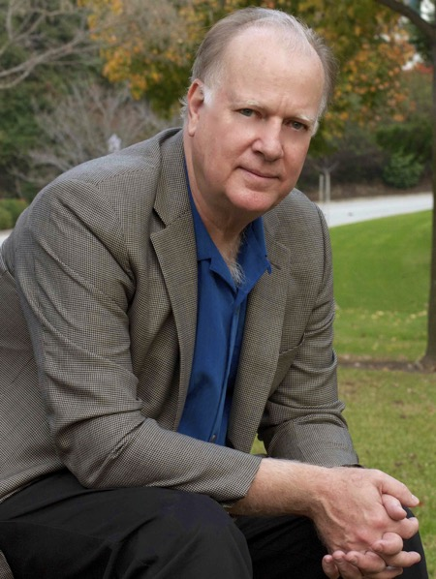

From Several Examples You’ll learn:

* How to discover the true heart of your novel
* How that knowledge brings both beginning and end into focus
* How this method can be used at any time during the writing process

Have your WIP handy as there will be exercises.

JAMES SCOTT BELL is a winner of the International Thriller Writers Award and the author of the #1 bestseller for writers, Plot & Structure (Writer’s Digest Books). He has taught writing at Pepperdine University and at numerous writers conferences in the United States, Canada, Great Britain, Australia and New Zealand. He appeared as an expert commentator on Good Morning America, CBS radio, and in Newsweek magazine during the O. J. Simpson murder trial. His book on search and seizure law is the leading authority in its field, used extensively by lawyers and judges throughout California every day. He lives in LosAngeles. His [thrillers](https://www.jamesscottbell.com/styled-3/) include Romeo’s Rules, Romeo’s Way and Romeo’s Hammer (the Mike Romeo thriller series); Try Dying, Try Darkness and Try Fear (the Ty Buchanan legal thriller series); and stand-alones including Your Son Is Alive and Final Witness (which won the first Christy Award for Suspense). He served as the fiction columnist for Writer's Digest magazine and has written several popular writing books, including Just Write, Conflict & Suspense, and The Art of War for Writers (all from Writer’s Digest Books). He’s also published How to Write Dazzling Dialogue, Write Your Novel From the Middle <https://www.amazon.com/dp/B00IMIXI6U>, Super Structure, and How to Make a Living as a Writer. Links to all his writing books may be found [HERE](https://www.jamesscottbell.com/styled-8/).

**Check into the Zoom Invitation at 9:30,** **Workshop 10:00 – 12:00. Members Cost: $15, Guests $20**